## 

**ENGINEERING CHEMISTRY**

**F. Y. B. Tech.**

**(First Year Semester I/ II)**

**Academic Year 2023-2024**

**SVU R- 2023**

Instructions to the student

* Every student is expected to bring printouts of laboratory write-up/ assignments to be performed at the time of practical session as per his/ her schedule.
* Every student should take counter signature of the concerned faculty in-charge on the same day during laboratory session for the verification of outcomes of the experiment/ assignment.
* The journal would consist of all the experiments performed during the academic semester complete in all respect along with graded term test papers. The journal may contain additional assignments as prescribed by the concerned faculty in-charge.
* The journal shall content A-4 size papers unless it is instructed for a particular subject.
* The students can use additional A-4 sheets if necessary for writing journal
* Every experiment/ assignment should bear a cover page in standard format given with this write-up file.
* The contents/ index of the journal should be as per the standard format given with this write-up file.
* Students are expected to follow the instructions given by concerned faculty during laboratory session from time to time.

COMMON LABORATORY GLASSWARES

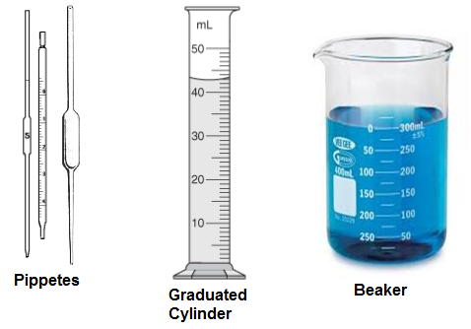

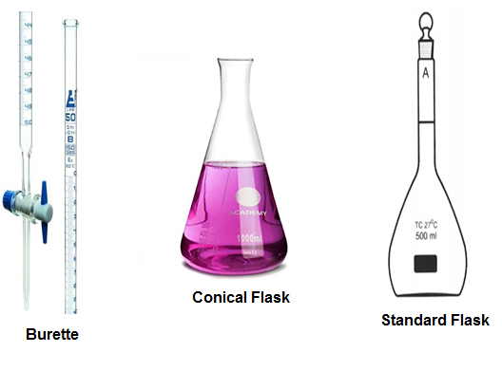

**Subject: Enginnering Chemistry**

**CO1:** Identify and evaluate emerging technologies and best practices in water treatment and monitoring to continuously improve process.

**Name:**

**Batch:**

**Roll No.: Date**

**Experiment No. 2**

Title : Determination of Hardness of Water

Aim : To determine the hardness of water using EDTA method.

Apparatus : Burette, pipette, conical flask etc.

Requirement : Standard hard water, Unknown water sample, 0.01M EDTA soln.,

Eriochrome Black-T indicator, Buffer of pH 10

Theory : Hardness of water is due to presence of salts of magnesium, and calcium in water. Total hardness is the sum of Temporary hardness and permanent hardness. Temporary hardness is due to the presence of bi carbonates of Calcium and Magnesium which easily get decomposed when heated and form carbonates. Permanent hardness is due to sulphates, chlorides, nitrates of Calcium and Magnesium. The Disodium salt of Ethylene Diamine tetra-acetic acid is widely used in the analysis of water because it forms stable metal complexes. The efficiency of complex formation with EDTA is affected by variation of pH of the solution and is favorable in basic soln. therefore to get better results alkaline buffer of NH4OH and NH4Cl is used. The indicator Eriochrome Black-T forms less stable (red or violet) complex with metal ion. Hence gets dissociated when titrated against EDTA soln. due to less stability.

**Procedure :**

Part I

Pipette out 10 mL standard hard water a (1mg/mL) in conical flask. Add 1/5 test tube of buffer of pH 10. Add pinch of Eriochrome Black-T indicator. Titrate against EDTA soln. from burette till color changes from Wine red to blue. Note down constant burette reading. Let it be V1 mL.

Part II

Pipette out 50 mL of unknown water sample B in a conical flask. Add 1/5 test tube buffer and Eriochrome Black-T indicator. Titrate against EDTA till color changes from Wine red to blue. Note down the constant burette reading. Let it be V2 mL.

Part III

Boil 50 mL of unknown water sample B for half an hour. Cool and filter it. Titrate against EDTA soln. from burette using Eriochrome black-T indicator. Color changes from Wine red to blue. Let this reading be V3 mL.

**Part I**

**Observation**

Burette : 0.01M EDTA soln.

Conical flask : 10 mL of Standard hard water + few crystals of Eriochrome Black-T +1 dropper Buffer of pH 10

Indicator : Eriochrome Black –T.

End point : Wine red to blue

Reaction:

Metal + indicator Metal-indicator complex (Wine red)

Metal-indicator complex + EDTA Free acid indicator (Blue) + Metal- EDTA complex (Colorless).

# Pilot Reading : __________ (mL) to __________(mL)

|  |  |  |  |  |
| --- | --- | --- | --- | --- |
| Reading | I (mL) | II (mL) | III (mL) | Constant (mL) |
| Initial |  |  |  | V1 |
| Final |  |  |  |
| Difference |  |  |  |

**Part II**

**Observation**

Burette : 0.01M EDTA soln.

Conical flask : 50 mL unknown water sample A + 1 dropper buffer of

pH 10 + few crystals of indicator

Indicator : Eriochrome Black-T

End point : Wine red to blue

# Observation:

# Pilot Reading : __________ (mL) to __________(mL)

|  |  |  |  |  |
| --- | --- | --- | --- | --- |
| Reading | I (mL) | II (mL) | III (mL) | Constant (mL) |
| Initial |  |  |  | V2 |
| Final |  |  |  |
| Difference |  |  |  |

**Calculation of Part II**

V1 mL of EDTA = …… mg of CaCO3

V2 mL of EDTA = V2/V1 x 10 = ______________

= X mg of CaCO3 equivalent hardness present in 50 ml of sample

= ___________ mg

50 mL of sample = X mg of CaCO3 hardness = __________

So, 1000 mL of sample = 20X mg CaCO3 equivalent hardness= _______mg

Total Hardness = __________________ ppm of CaCO3 equivalents

**Part III**

**Observations**

Burette : 0.01M EDTA soln.

Conical flask : 50 mL hard water sample boiled B +1 dropper buffer of pH 10 + few crystals of indicator

Indicator : Eriochrome Black-T

End point : Wine red to blue

Observation table:

# Pilot Reading : __________ (mL) to __________(mL)

|  |  |  |  |  |
| --- | --- | --- | --- | --- |
| Reading | I (mL) | II (mL) | III (mL) | Constant (mL) |
| Initial |  |  |  | V3 |
| Final |  |  |  |
| Difference |  |  |  |

**Calculation of Part III:**

Constant burette reading = V3 mL = ______ ml

V1 ml of EDTA = 10 mg of CaCO3 equivalent hardness

V3 ml of EDTA = V3/V1 x 10 = _______

50 mL of sample = Y mg of CaCO3 hardness = ______

1000 mL of sample = 20Y mg CaCO3 equivalent hardness

= ppm

Permanent hardness of water sample = _______________ in ppm of CaCO3

**Results:** Total hardness of water sample =__________________ ppm

Permanent hardness of water sample =___________________ppm

Temporary hardness of water sample = ___________________ ppm